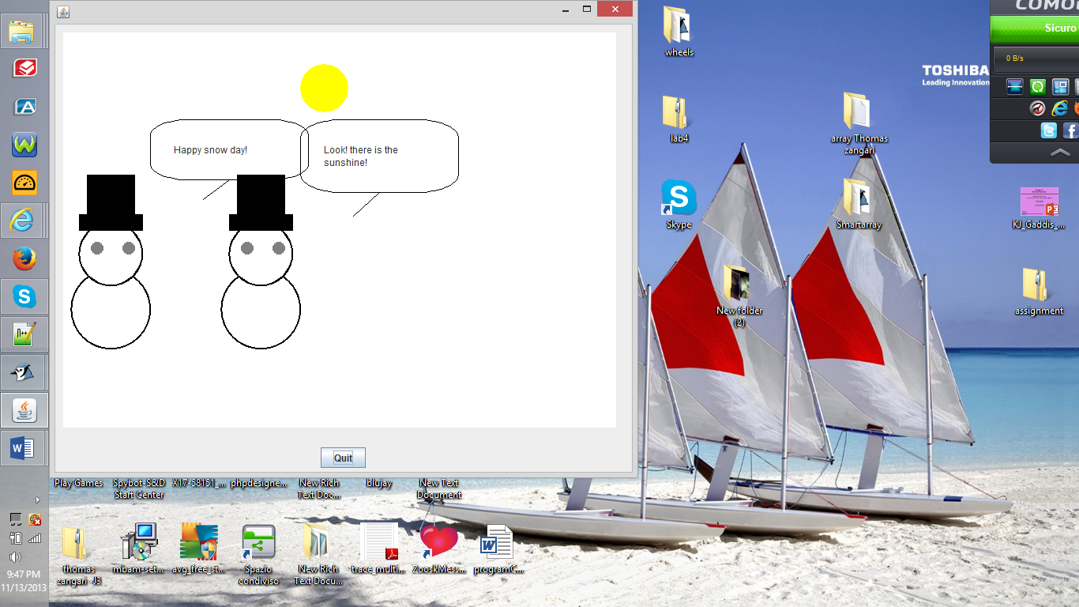

/**

* Write a description of class SnowPeople here.

*

* @author (your name)

* @version (a version number or a date)

*/

import wheels.users.*;

public class SnowPicture extends Frame{

// instance variables - replace the example below with your own

private Snowman _snowman;

private Snowman _snowman2;

private Hat _hat;

private Hat _hat2;

private Ellipse _sun;

private ConversationBubble _bubble;

private ConversationBubble _bubble2;

public SnowPicture() {

_snowman = new Snowman(10,240);

_snowman2 = new Snowman( 200, 240);

_hat = new Hat(_snowman);

_hat2 = new Hat (_snowman2);

_sun = new Ellipse(java.awt.Color.yellow);

_sun.setLocation(300,40);

_sun.setSize(60,60);

_bubble = new ConversationBubble("Happy snow day!",ConversationBubble.TAIL_DIR_LEFT);

_bubble2 = new ConversationBubble("Look! there is the sunshine!",ConversationBubble.TAIL_DIR_LEFT);

_bubble.setLocation(110,110);

_bubble2.setLocation(300,110);

}

public static void main(String[] args){

SnowPicture picture = new SnowPicture();

}

}

----------------------------------------------------------------------------------------------------------------------

/**

* Write a description of class Hat here.

*

* @author (Thomas Zangari)

* @version (11/13/2013)

*/

import wheels.users.*;

import java.awt.Color;

public class Hat

{

// instance variables - replace the example below with your own

private Rectangle _hatBrim;

private Rectangle _hatUpper;

public Hat(Snowman mySnowman) {

_hatBrim = new Rectangle();

_hatUpper = new Rectangle();

this.setColor(Color.BLACK);

this.setSize(60,60);

this.setLocation(mySnowman.getX() + 10, mySnowman.getY() - 60);

}

public void setColor(Color c){

_hatBrim.setColor(c);

_hatUpper.setColor(c);

}

public void setSize(int w,int h){

_hatUpper.setSize(w, h);

_hatBrim.setSize((w*4)/3,h/3);

}

public void setLocation(int x, int y){

_hatBrim.setLocation(x, y + 50);

_hatUpper.setLocation(x + 10, y);

}

}

/**

* Write a description of class Snowman here.

*

* @author (your name)

* @version (a version number or a date)

*/

import wheels.users.*;

import java.awt.Color;

public class Snowman

{

private Ellipse _head, _body, _leftEye, _rightEye;

private int _x, _y;

public Snowman(int x, int y){

_body = new Ellipse();

_head = new Ellipse();

_leftEye = new Ellipse();

_rightEye = new Ellipse();

_x = x;

_y = y;

this.setColor(Color.WHITE, Color.GRAY);

this.setSize();

this.setLocation(x,y);

this.setOutline(java.awt.Color.black,2);

}

public void setColor (Color snowColor, Color eyeColor){

_body.setColor(snowColor);

_head.setColor(snowColor);

_rightEye.setColor(eyeColor);

_leftEye.setColor(eyeColor);

}

public void setSize(){

_body.setSize(100,100);

_head.setSize(80,80);

_leftEye.setSize(15,15);

_rightEye.setSize(15,15);

}

public void setOutline(java.awt.Color color, int thickness){

_body.setFrameColor(color);

_body.setFrameThickness(thickness);

_head.setFrameColor(color);

_head.setFrameThickness(thickness);

}

public int getX(){

return _x;

}

public int getY(){

return _y;

}

public void setLocation(int x, int y){

_x = x ;

_y = y;

_body.setLocation(_x, _y + 60);

_head.setLocation(_x + 10, _y);

_leftEye.setLocation(_x + 25, _y + 25);

_rightEye.setLocation(_x + 65, _y + 25);

}

}